IASON KOTAKIS 214617732
I have read and understood the Academic Honesty Statement specified in the course outline, and I have adhered fully at all time to the academic honesty rules and policies laid by the instructor, the School of Information Technology and York University Senate’s Academic Integrity Policy.

Question 1:
StudentBody.java

public class StudentBody {
public static void main(String[] args)
{
Address school = new Address("800 Lancaster Ave", "Villanova", "PA", 19085);
Address jHome = new Address("21 Jump Street","Lynchburg", "VA", 24551);
Student john = new Student("John","Smith", jHome,school, 80, 90, 85);
Address mHome = new Address("123 Main Street","Euclid","OH", 44132);
Student marsha = new Student("Marsha","Jones",
mHome, school, 77, 99, 88);
System.out.println(john);
System.out.println();
System.out.println (marsha);
john.setTestScore(2,75);
System.out.println("\nAfter set the test score2 to the John, the details would be:"+john);
System.out.println("\nThe score of test 3 of Marsha:"+marsha.getTestScore(3));
}

}

Student.java

public class Student {
private String firstName, lastName;
private Address homeAddress, schoolAddress;
private int score1,score2, score3;
public Student()
{
score1=0;
score2=0;
score3=0;
}

public Student(String first, String last,Address home,Address school,int test1,int test2 ,int test3)
{
firstName = first;
lastName = last;
homeAddress = home;
schoolAddress = school;
score1 = test1;
score2 = test2;
score3 = test3;
}

public void setTestScore(int test,int score)
{
if (test==1)
score1=score;
else if(test ==2)
score2=score;
else if(test == 3)
score3=score;
else
{
System.out.println("Wrong input test number should be 1 or 2 or 3");
System.exit(0);
}
}
public int getTestScore(int test)
{
int score=-1;
if (test==1)
score=score1;
else if(test ==2)
score = score2;
else if(test == 3)
score=score3;
else
{
System.out.println("Wrong input test number should be 1 or 2 or 3");
System.exit(0);
}
return score;
}
public double average()
{
double sum=score1+score2+score3;
return sum/3;
}
public String toString()
{
String result;
result=firstName+""+lastName+"\n";
result+="Home Address:\n"+homeAddress+"\n";
result+="School Address:\n"+schoolAddress+"\n";
result+= "Three test scores:\nTest1:"+getTestScore(1)+"\nTest2:"+getTestScore(2)+"\nTest3:"+getTestScore(3)+"\n";
result+="The average of three test scores:"+average();
return result;

}
}

Address.java

public class Address {
private String streetAddress,city,state;
private long zipCode;
public Address(String street,String town,String st,long zip)
{
streetAddress=street;
city=town;
state=st;
zipCode=zip;
}
public String toString()
{
String result;
result=streetAddress+"\n";
result+=city+","+state+","+zipCode;
return result;

}

}

Output:

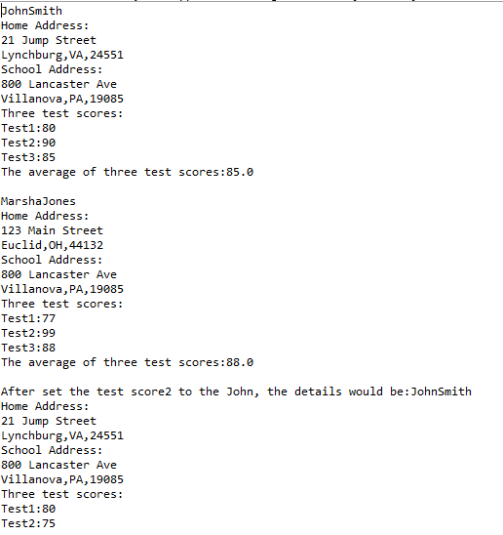

Question 2:

Driver.java

public class Driver {

public static void main(String[] args)
{
Address school = new Address("800 Lancaster Ave", "Villanova", "PA", 19085);
Address jHome = new Address("21 Jump Street","Lynchburg", "VA", 24551);
Student john = new Student("John","Smith", jHome,school, 80, 90, 85);
Address mHome = new Address("123 Main Street","Euclid","OH", 44132);
Student marsha = new Student("Marsha","Jones",mHome, school, 77, 99, 88);
Address aHome = new Address("abc Street","Hyderabad", "OH",44787);
Student alex = new Student("Alex","Lee", jHome,school, 50, 60, 70);
Address mikeHome = new Address("123 pqr Street","Hyderabad", "OH",44777);
Student mike = new Student("Mike","Lee", mikeHome,school, 64, 68, 70);
Address GabrillaHome = new Address("123 pqr Street","Hyderabad", "OH",44774);
Student gabrilla = new Student("Gabrilla","Desuza", GabrillaHome,school, 64, 68, 70);
Course java=new Course("java");
java.addStudent(john);
java.addStudent(alex);
java.addStudent(gabrilla);
Course cpp=new Course("CPP");
cpp.addStudent(mike);
cpp.addStudent(marsha);
System.out.println("The following students are related to the course java:");
java.roll();
System.out.println("The following students are related to the course CPP:");
cpp.roll();
System.out.println("\nThe overall java course test average:"+java.average());
System.out.println("\nThe overall cpp course test average:"+cpp.average());

}

}

Course.java

import java.util.ArrayList;

public class Course {

private String name;
ArrayList<Student> students=new ArrayList<Student>();
public Course(String name)
{
this.name=name;
}
public double average()
{
double total=0.00;
double average=0.00;
for(Student student : students)
{
total+=student.average();
}
average=total/students.size();
return average;
}
public void roll()
{
System.out.println("Course: "+name);
System.out.println("Students:");

for(Student student : students)
{
System.out.println("\n"+student.toString());
}
}
public void addStudent(Student student) {
students.add(student);
}
}

Student.java

package Firm_new;

public class Student {
private String firstName, lastName;
private Address homeAddress, schoolAddress;
private int score1,score2, score3;
public Student()
{
score1=0;
score2=0;
score3=0;
}

public Student(String first, String last,Address home,Address school,int test1,int test2 ,int test3)
{
firstName = first;
lastName = last;
homeAddress = home;
schoolAddress = school;
score1 = test1;
score2 = test2;
score3 = test3;
}

public void setTestScore(int test,int score)
{
if (test==1)
score1=score;
else if(test ==2)
score2=score;
else if(test == 3)
score3=score;
else
{
System.out.println("Wrong input test number should be 1 or 2 or 3");
System.exit(0);
}
}
public int getTestScore(int test)
{
int score=-1;
if (test==1)
score=score1;
else if(test ==2)
score = score2;
else if(test == 3)
score=score3;
else
{
System.out.println("Wrong input test number should be 1 or 2 or 3");
System.exit(0);
}
return score;
}
public double average()
{
double sum=score1+score2+score3;
return sum/3;
}
public String toString()
{
String result;
result=firstName+""+lastName+"\n";
result+="Home Address:\n"+homeAddress+"\n";
result+="School Address:\n"+schoolAddress+"\n";
result+= "Three test scores:\nTest1:"+getTestScore(1)+"\nTest2:"+getTestScore(2)+"\nTest3:"+getTestScore(3)+"\n";
result+="The average of three test scores:"+average();
return result;

}
}

Address.java

package Firm_new;

public class Address {
private String streetAddress,city,state;
private long zipCode;
public Address(String street,String town,String st,long zip)
{
streetAddress=street;
city=town;
state=st;
zipCode=zip;
}
public String toString()
{
String result;
result=streetAddress+"\n";
result+=city+","+state+","+zipCode;
return result;

}

}

Output:
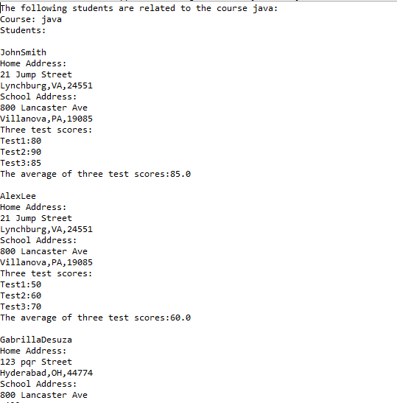

Question 3:
Implementation.java

class ReadingMaterial
{
String type;
int noofpages;
ReadingMaterial()
{
type = "Book";
noofpages = 1000;
}
ReadingMaterial(String t, int n)
{
type = t;
noofpages = n;
}
void print()
{
System.out.println("Reading Material Type:" + type);
System.out.println("Number of Pages" + noofpages);
}
}
class Book extends ReadingMaterial
{
String primarychar1;
String primarychar2;
String primarychar3;

Book()
{
super();
primarychar1 = "A";
primarychar2 = "B";
primarychar3 = "C";
}
Book(String a,int n,String b,String c,String d)
{
super(a,n);
primarychar1 = b;
primarychar2 = c;
primarychar3 = d;
}
void print()
{
super.print();
System.out.println("Primary Character :" + primarychar1);
System.out.println("Primary Character :" + primarychar2);
System.out.println("Primary Character :" + primarychar3);
}
}
class Novel extends ReadingMaterial
{
String primarychar1;
String primarychar2;
String primarychar3;

Novel()
{
super();
primarychar1 = "A";
primarychar2 = "B";
primarychar3 = "C";
}
Novel(String a,int n,String b,String c,String d)
{
super(a,n);
primarychar1 = b;
primarychar2 = c;
primarychar3 = d;
}
void print()
{
super.print();
System.out.println("Primary Character :" + primarychar1);
System.out.println("Primary Character : "+ primarychar2);
System.out.println("Primary Character : "+ primarychar3);
}
}
class Magazine extends ReadingMaterial
{
String primarychar1;
String primarychar2;
String primarychar3;

Magazine()
{
super();
primarychar1 = "A";
primarychar2 = "B";
primarychar3 = "C";
}
Magazine(String a,int n,String b,String c,String d)
{
super(a,n);
primarychar1 = b;
primarychar2 = c;
primarychar3 = d;
}
void print()
{
super.print();
System.out.println("Primary Character :" + primarychar1);
System.out.println("Primary Character :" + primarychar2);
System.out.println("Primary Character :" + primarychar3);
}
}
class TechnicalJournal extends ReadingMaterial
{
String primarychar1;
String primarychar2;
String primarychar3;

TechnicalJournal()
{
super();
primarychar1 = "A";
primarychar2 = "B";
primarychar3 = "C";
}
TechnicalJournal(String a,int n,String b,String c,String d)
{
super(a,n);
primarychar1 = b;
primarychar2 = c;
primarychar3 = d;
}
void print()
{
super.print();
System.out.println("Primary Character :" + primarychar1);
System.out.println("Primary Character :" + primarychar2);
System.out.println("Primary Character :" + primarychar3);
}
}
class TextBook extends ReadingMaterial
{
String primarychar1;
String primarychar2;
String primarychar3;

TextBook()
{
super();
primarychar1 = "A";
primarychar2 = "B";
primarychar3 = "C";
}
TextBook(String a,int n,String b,String c,String d)
{
super(a,n);
primarychar1 = b;
primarychar2 = c;
primarychar3 = d;
}
void print()
{
super.print();
System.out.println("Primary Character :" + primarychar1);
System.out.println("Primary Character :" + primarychar2);
System.out.println("Primary Character :" + primarychar3);
}
}
class Implementation
{
public static void main(String args[])
{
ReadingMaterial r = new ReadingMaterial();
r.print();
Book b = new Book();

b.print();
Book b1 = new Book("Book",100,"Primary 1","Primary 2","Primary 3");
b1.print();
Novel n = new Novel();
n.print();
Novel n1 = new Novel("Novel",100,"Primary 1","Primary 2","Primary 3");
n1.print();

Magazine m = new Magazine();
m.print();
Magazine m1 = new Magazine("Magazine",100,"Primary 1","Primary 2","Primary 3");
m1.print();

TechnicalJournal t = new TechnicalJournal();
t.print();
TechnicalJournal t1 = new TechnicalJournal("TechnicalJournal",100,"Primary 1","Primary 2","Primary 3");
t1.print();

TextBook tb = new TextBook();
tb.print();
TextBook tb1 = new TextBook("TextBook",100,"Primary 1","Primary 2","Primary 3");
tb1.print();
}
}

Output :

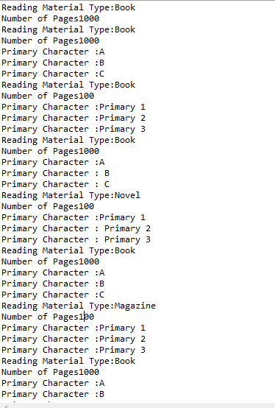

Question 4

Firm.java

package Firm_new;

public class Firm
{
public static void main (String[] args)
{
Staff personnel = new Staff();
personnel.printVacationDays();
}
}

Staff.java

package Firm_new;

public class Staff
{
private StaffMember[] staffList;
public Staff ()
{
staffList = new StaffMember[4];

staffList[0] = new Executive ("Sam", "123 Main Line",
"555-0469", "123-45-6789", 2423.07);
staffList[1] = new Employee ("Carla", "456 Off Line",
"555-0101", "987-65-4321", 1246.15);
staffList[2] = new Employee ("Woody", "789 Off Rocker",
"555-0000", "010-20-3040", 1169.23);
staffList[3] = new Hourly ("Diane", "678 Fifth Ave.",
"555-0690", "958-47-3625", 10.55);
}

public void printVacationDays ()
{
System.out.println("Get vacation Days : ");
for (int count=0; count < staffList.length; count++)
{
System.out.println(staffList[count]);
System.out.println ("Vacation Days : "+staffList[count].getVacationDays());
System.out.println ("-----------------------------------");
}
}
}

Employee.java

package Firm_new;

public class Employee extends StaffMember
{
protected String socialSecurityNumber;
protected double payRate;
public Employee (String eName, String eAddress, String ePhone,String socSecNumber, double rate)
{
super (eName, eAddress, ePhone);

socialSecurityNumber = socSecNumber;
payRate = rate;
}
public String toString()
{
String result = super.toString();

result += "\nSocial Security Number: " + socialSecurityNumber;

return result;
}

public double pay()
{
return payRate;
}

/*Override getVacationDays method*/
public double getVacationDays() {
return VACATION_DAYS;
}
}

StaffMember.java

package Firm_new;
abstract public class StaffMember
{
protected int VACATION_DAYS=12;
protected String name;
protected String address;
protected String phone;

public StaffMember (String eName, String eAddress, String ePhone)
{
name = eName;
address = eAddress;
phone = ePhone;
}

public String toString()
{
String result = "Name: " + name + "\n";

result += "Address: " + address + "\n";
result += "Phone: " + phone;

return result;
}

public abstract double pay();
public abstract double getVacationDays();
}

Executive.java

package Firm_new;

public class Executive extends Employee
{
private double bonus;
private int EXTRA_VAC_DAYS=5;
public Executive (String eName, String eAddress, String ePhone,
String socSecNumber, double rate)
{
super (eName, eAddress, ePhone, socSecNumber, rate);
bonus = 0; // bonus has yet to be awarded
}

public void awardBonus (double execBonus)
{
bonus = execBonus;
}

public double pay()
{
double payment = super.pay() + bonus;

bonus = 0;

return payment;
}
public double getVacationDays() {
return super.getVacationDays()+EXTRA_VAC_DAYS;
}
}

Hourly.java

package Firm_new;

public class Hourly extends Employee
{
private int hoursWorked;
private int EXTRA_VAC_DAYS=2;
public Hourly (String eName, String eAddress, String ePhone,
String socSecNumber, double rate)
{
super (eName, eAddress, ePhone, socSecNumber, rate);
hoursWorked = 0;
}

public void addHours (int moreHours)
{
hoursWorked += moreHours;
}

public double pay()
{
double payment = payRate * hoursWorked;

hoursWorked = 0;

return payment;
}
public String toString()
{
String result = super.toString();

result += "\nCurrent hours: " + hoursWorked;

return result;
}
public double getVacationDays() {
return super.getVacationDays()+EXTRA_VAC_DAYS;
}

}
Output :

